Verification Environment Specification of APB to BURST Module
S.C. EasyIC Design S.R.L
Ciomag Andrei Daniel

APB to BURST Overview
The APB to BURST block can make read or write transactions using the burst method. The maximum size for the burst being in the range from 1 to 32 bytes

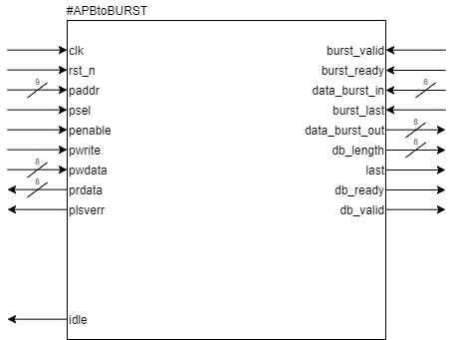Figure 1: APB to BURST input/ouptut interfaces

APB to BURST Features
- If the pwrite signal it’s HIGH the data will be receive from the APB interface and stored in the register bank.
- The start data address from the APB interface will always start from address 0. The maximum value for the address it is 255.
- When all the data it’s stored the start register will be set on 1 and the Data Burst controller will start transfer data as a burst with a length that it’s stored in the MAX_BURST_SIZE register.
- The value for the MAX_BURST_SIZE it is in the range from 1 to 32 bytes and the length in range from 1 to 255.
- When a transaction it’s initialized the idle signal it’s gonna be set on LOW, and when a transaction it’s finished it will be set back to the HIGH state.
- If the pwrite signal it’s LOW the data will be received as burst and stored into the register bank trough a Data Burst Controller.
- All the modules use a request-acknowledge interface for the data transfer.
- The register bank that contain 256 registers for the data, one that contain the length, one for read/write, one for the max_burst_size, one for start and one for rd_done.
- The pready signal will be high when a transfer it’s finished and the IDLE signal it’s back on HIGH.
- The pslverr signal will be set on high if we use a invalid address in the read/write process.

APB to BURST Interfaces
The APB to BURST module has the following interfaces:
- APB(Advanced Peripheral Bus)
- Burst Master Interface
The internal registers are shown in the Figure 2:
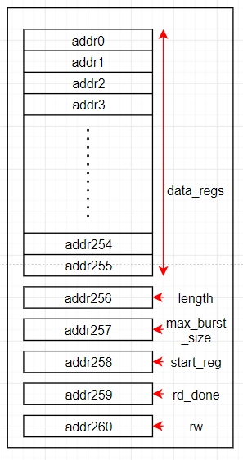
Figure 2: Internal Registers

Transactions
A transaction consists of several commands given on the APB. There are two types of commands on the APB, write and read.
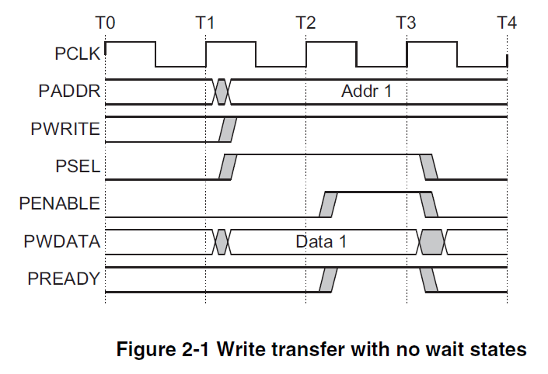
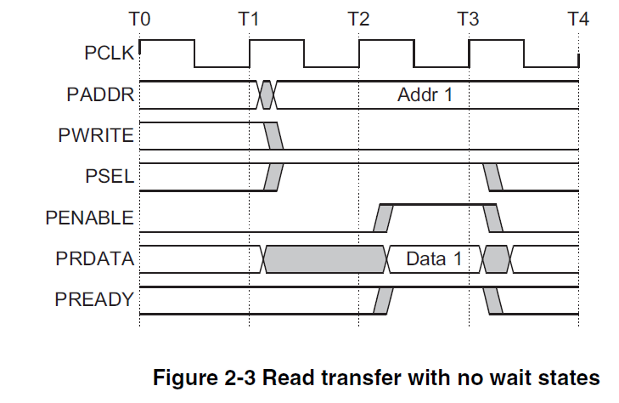
Figure 4: APB write transfer
Figure 3: APB read transfer

The APB to BURST module supports two types of transactions, write – which transfers data from the APB to burst, and a read transaction, which transfers the data from burst to the APB.
In the Figure 5 is shown a write transaction. In which the Length and Max Burst Size registers are configured, and after that the data is is written to the data registers in the Register Bank.
The configuration of the Start Register signals the APB to BURST the starting of the transaction.

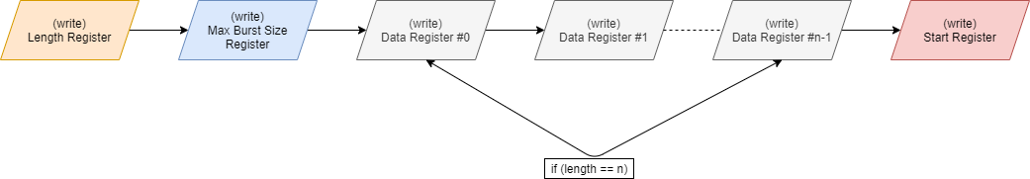Figure 5: Write transaction
For the read transaction, the Length and Start registers are configured, the pwrite signal is asserted to 0, and then the apb_rd_done signal is checked to start reading from the data registers. If the apb_rd_done signal is LOW, it means that the Burst Master is still writing the data do the registers.
The read transaction is illustrated in the Figure 6:
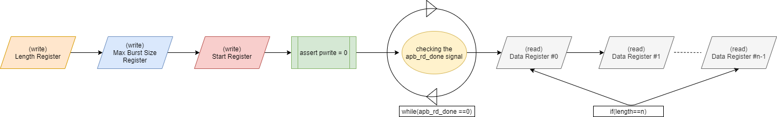Figure 6: Read transaction

Verification Plan

Stimulus Generation

Write Transaction:
- generate random length values for Length Register configuration
- generate random burst sizes between 1 and 32 for the Mac Burst Size Register configuration
- generate write APB transfers on Data Registers
- generate the Start Register configuration
- generate random cycles of burst_ready singal

Read Transaction:
- generate random length values for Length Register configuration
- generate bursts of data on the data_burst_in bus
- generate read APB transfers on Data Registers.

Verification Environment
The APB to BURST verification environment diagram is presented in Figure 7.

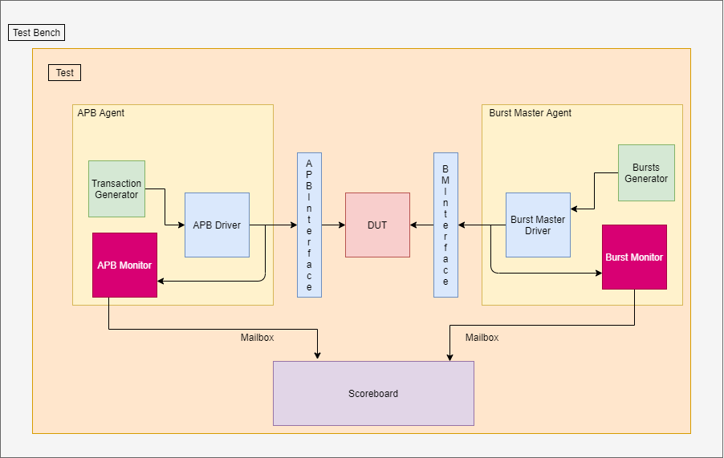Figure 7: Verification Environment

Components description
The Test bench instantiates the Design under Test (DUT) module and the Test case, and configures the connections betweeen them.
The Test is a top-level component that performs three main functions: instantiates the top-level environment, configures the environment and applies stimulus.
APB Agent and Burst Master Agent is a hierarchical component that groups together other verification components that are dealing with the APB and Burst Master interfaces.

Transaction Generator generates APB transfer objects for configuring the APB to BURST control registers and read or write APB transfers for the data registers.
Burst Generator generates bursts for the read transaction.
APB Driver and Bust Master Driver spans abstraction levels by converting transaction-level stimulus intro pin-level stimulus.
APB Monitor and Burst Master Monitor samples the DUT interfaces and captures the information there in transactions that are sent out to the rest of the Testbench for further analysis.
The Scoreboard’s main function is to compare the expected items to the received ones and check if the behavior of the DUT is as expected.

